WEEK-12

1 DEPLOYMENT OF INDEX.HTML USING EC2 INSTANCE in A

* Go to course invitation mail and click on start
* Opens the aws academy, select the student login and enter the email and password details
* Click on Modules
* Scroll down and select Lunch AWS Academy Lab-🡪 start Lab

Click on start lab

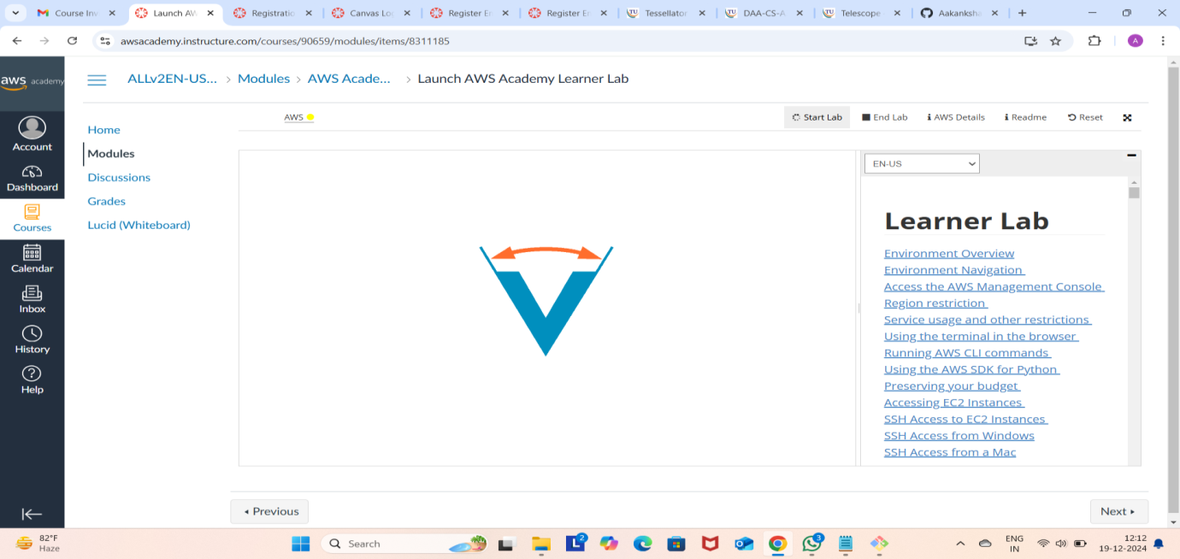

Click on AWS

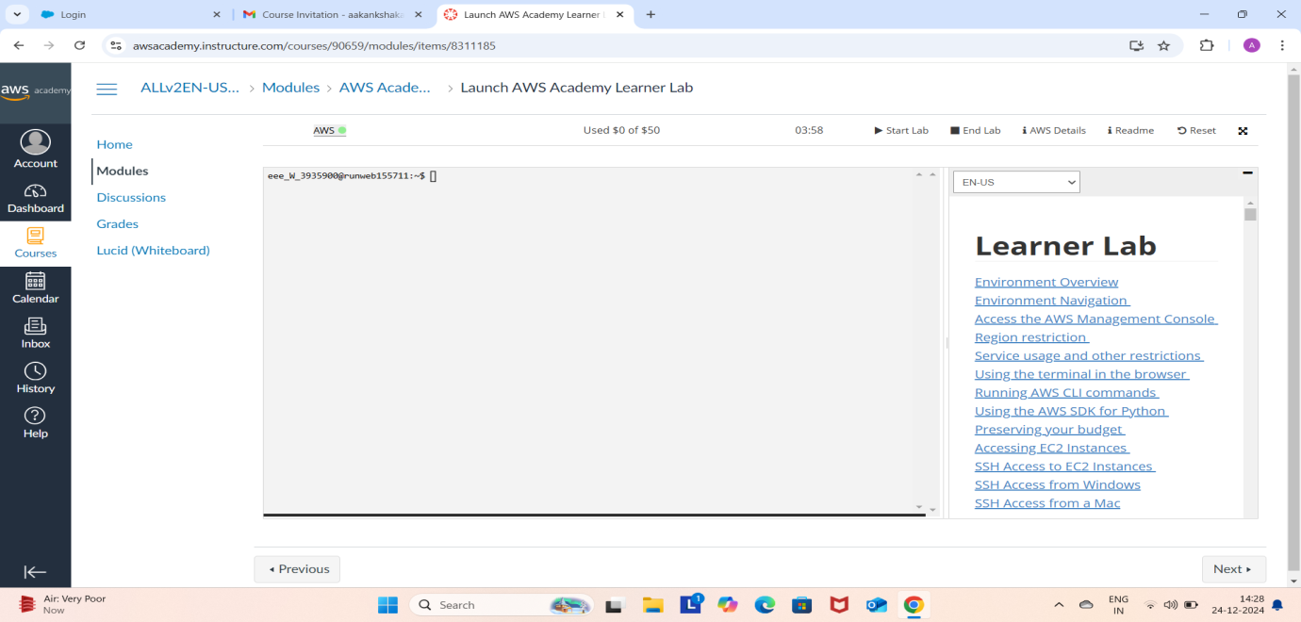

Click on EC2

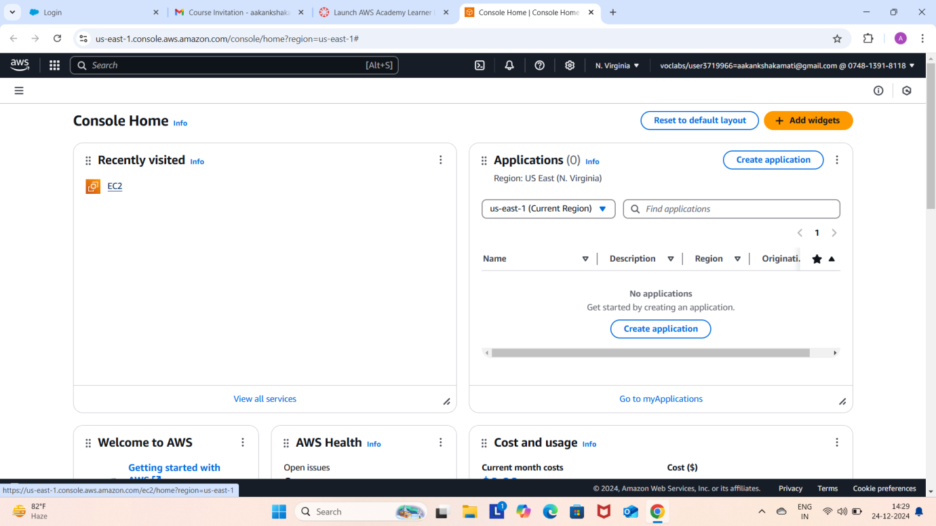

Click on Launch Instance

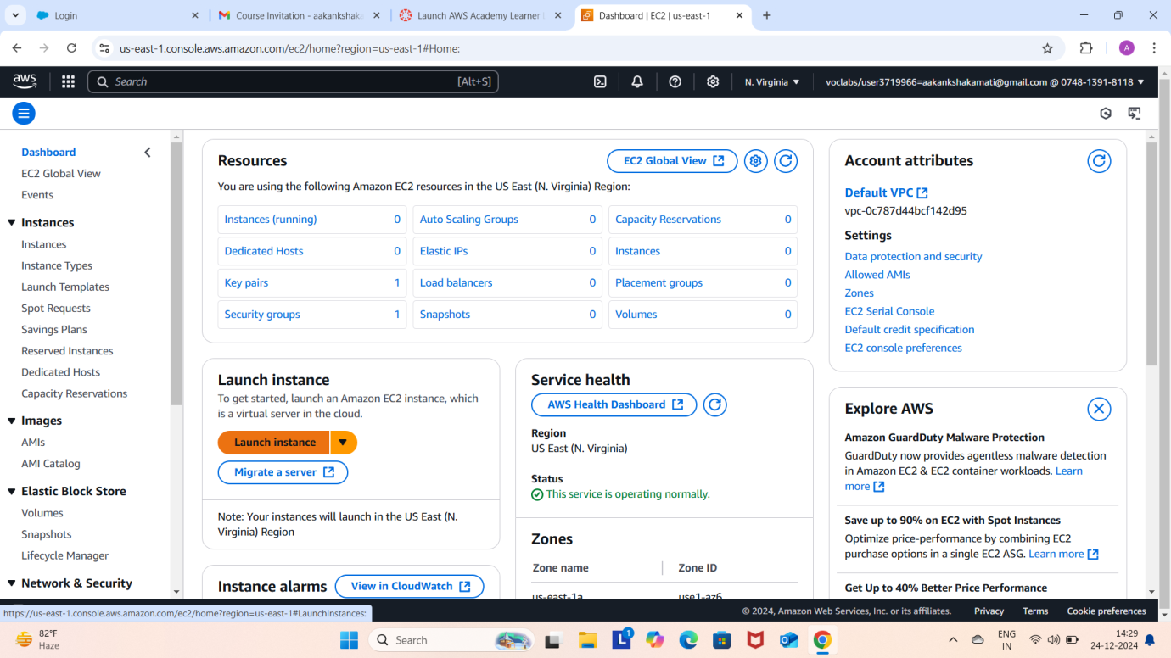

Give name and select ubuntu under application

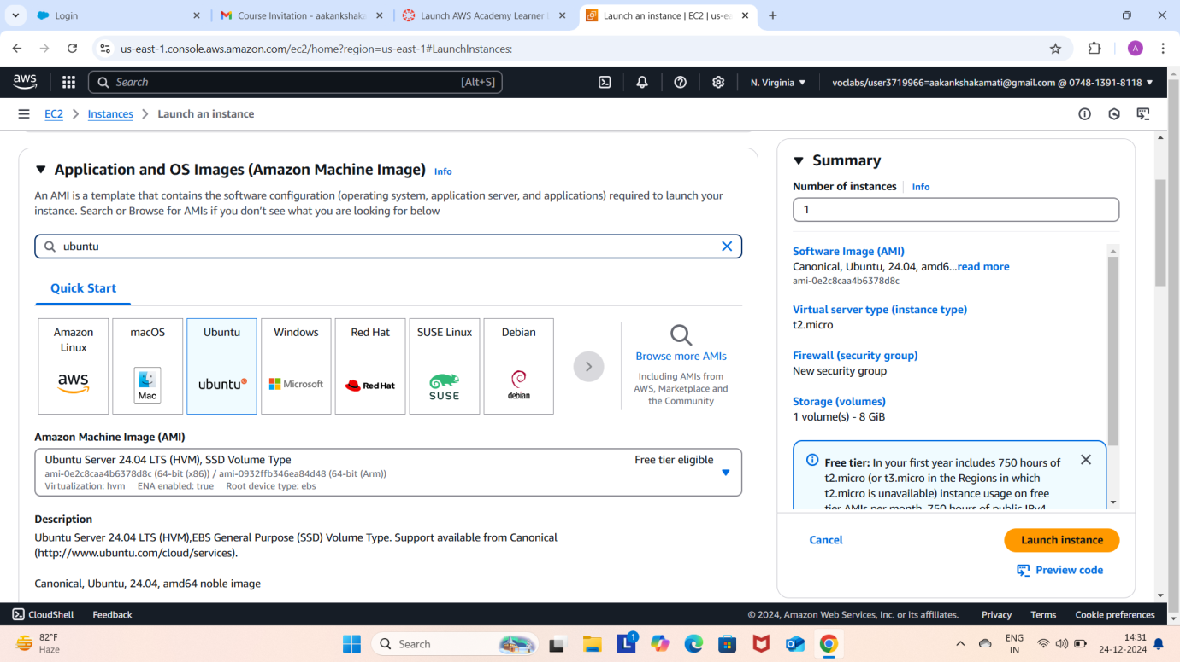

Make sure AMI and Architecture are there as shown

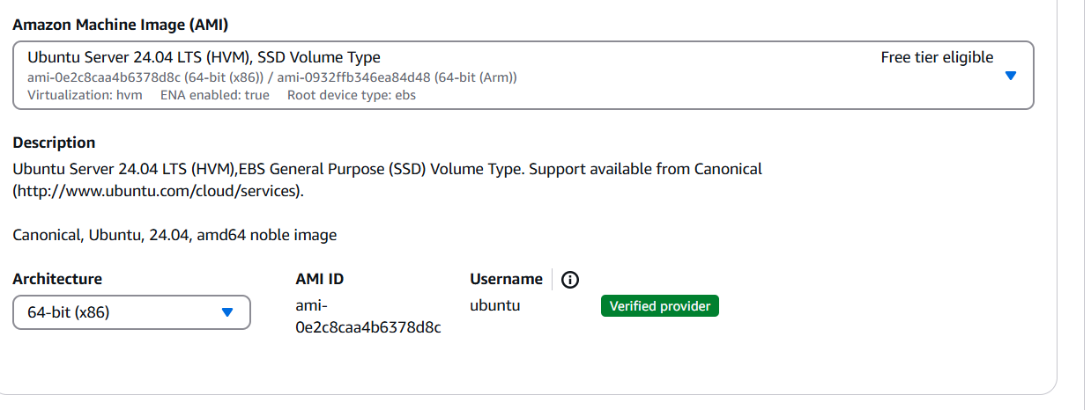

Click on create-new key pair

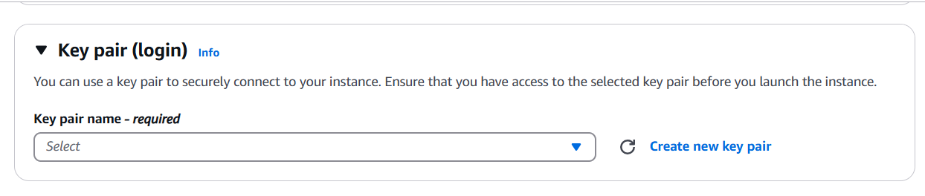

Give KeyPair name and click on create key pair

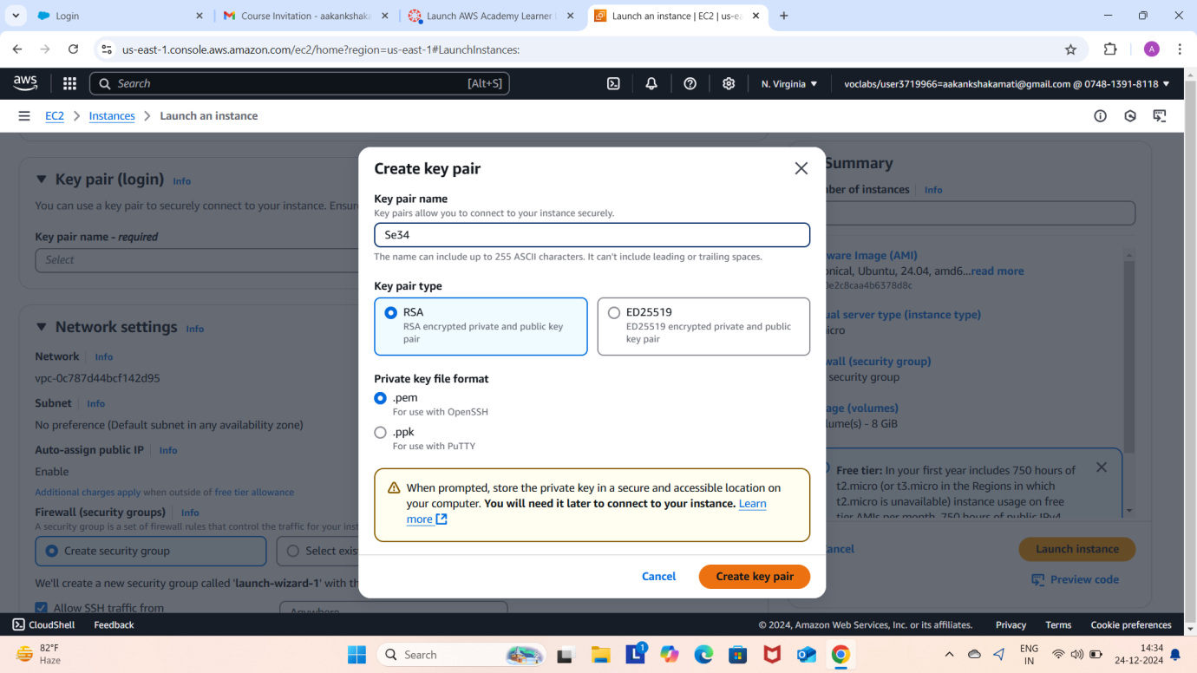

Save the .pem file

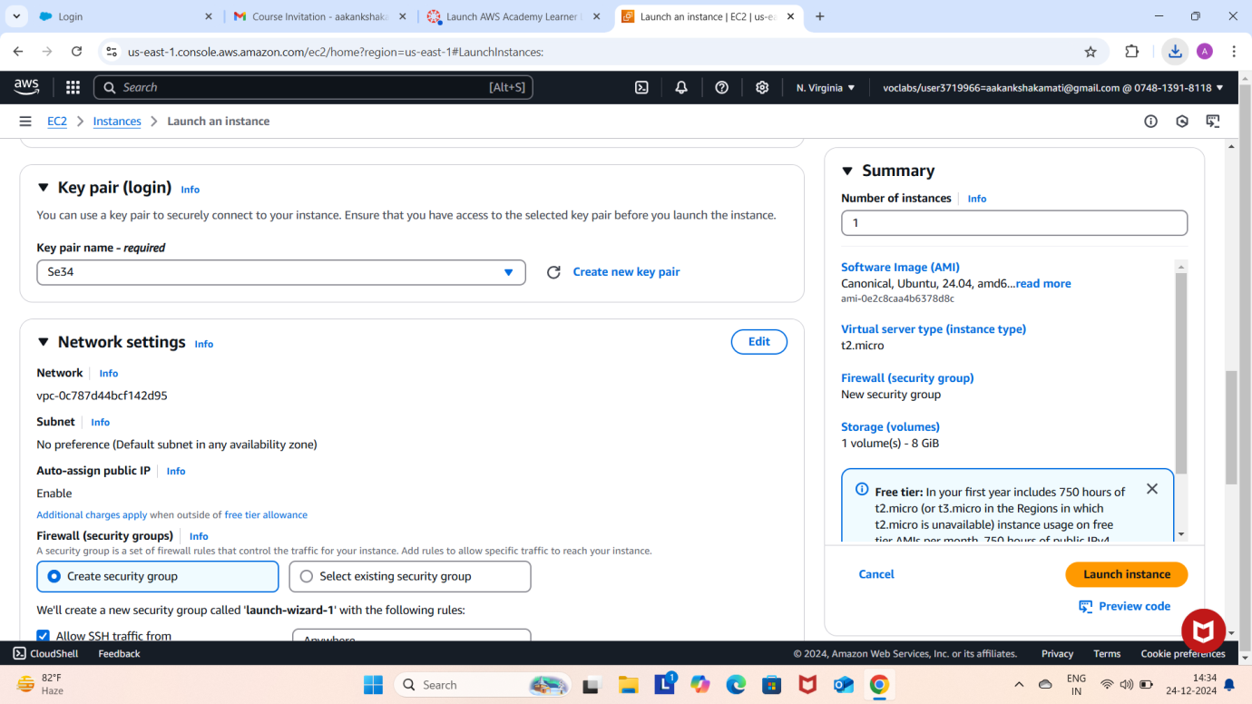

In network setting check all the checkboxes and click on launch instance which is at the bottom right to the page

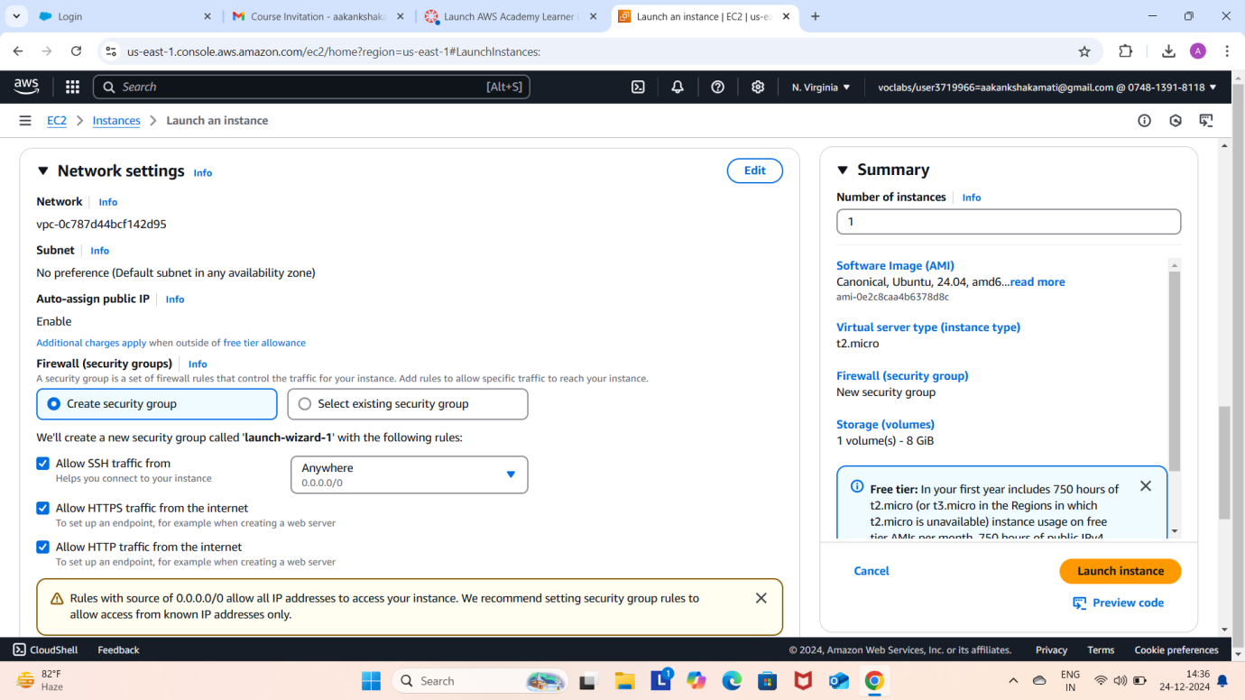

Wait for the Success message.

Now click on the instances

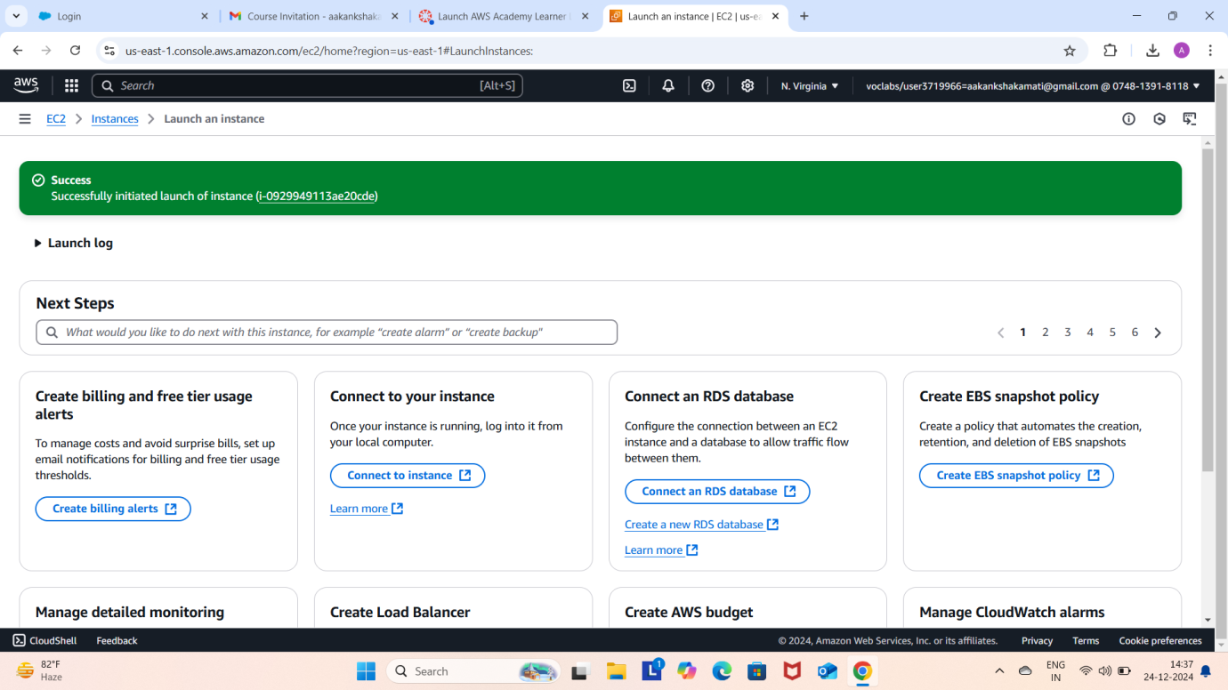

You can see ubuntu is Running and wait for it to initialize

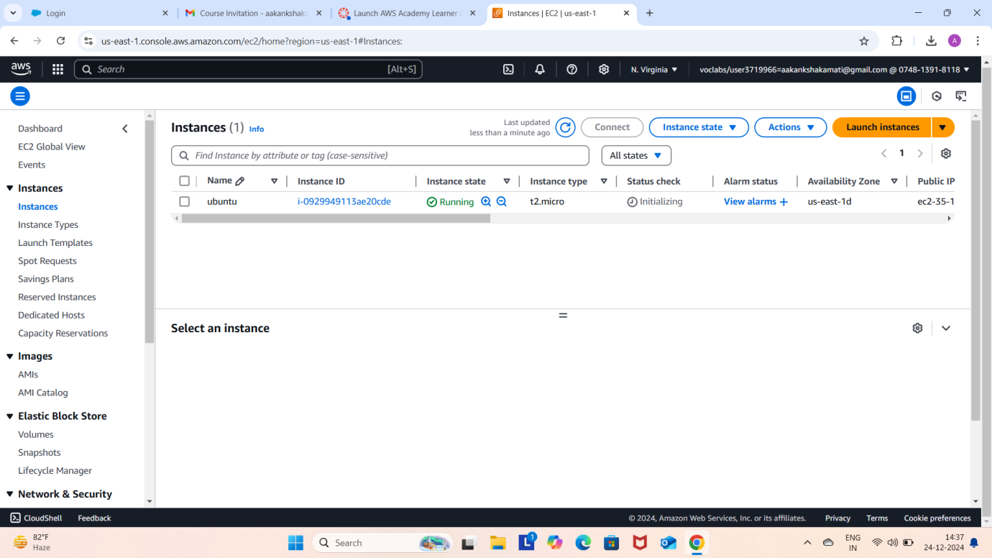

You have get 2 tests passes. Now check the box and click on connect.

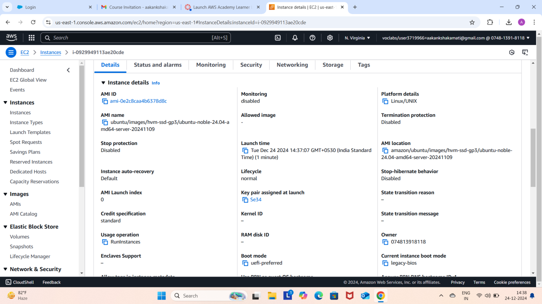

Copy the path of .pem file that you saved earlier

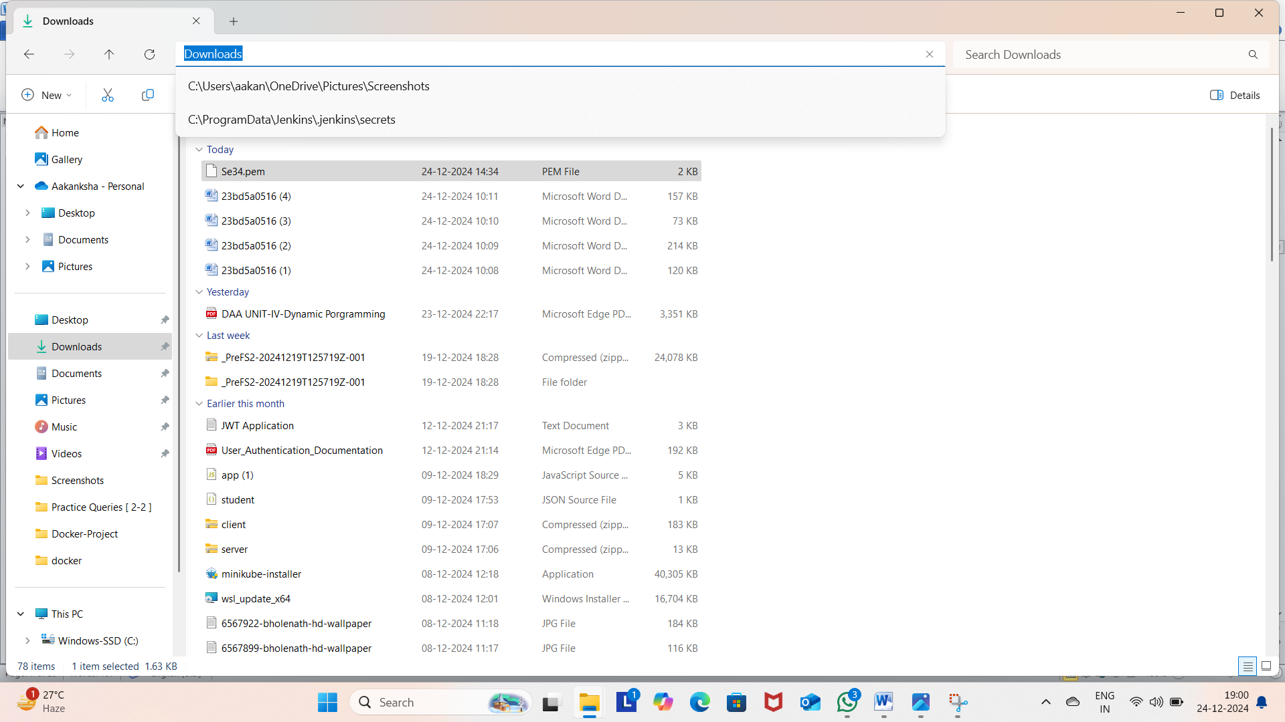

Open CMD and navigate to that path

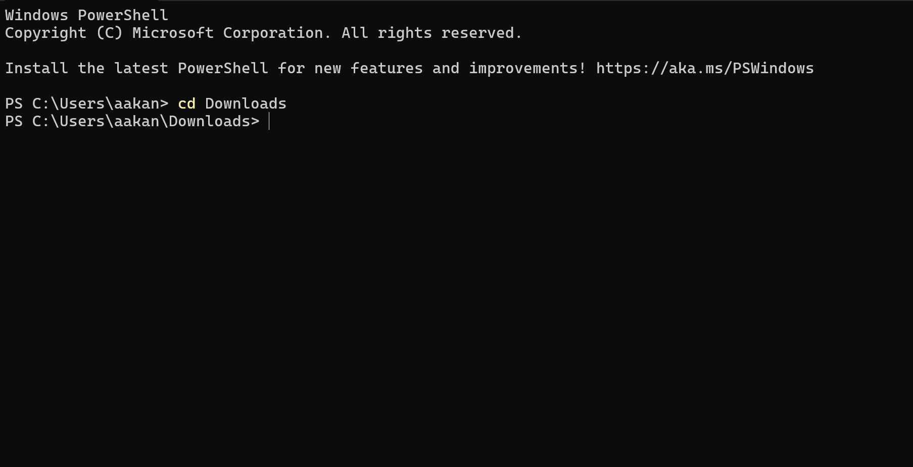

Go to SSh and copy the command which is present at the below

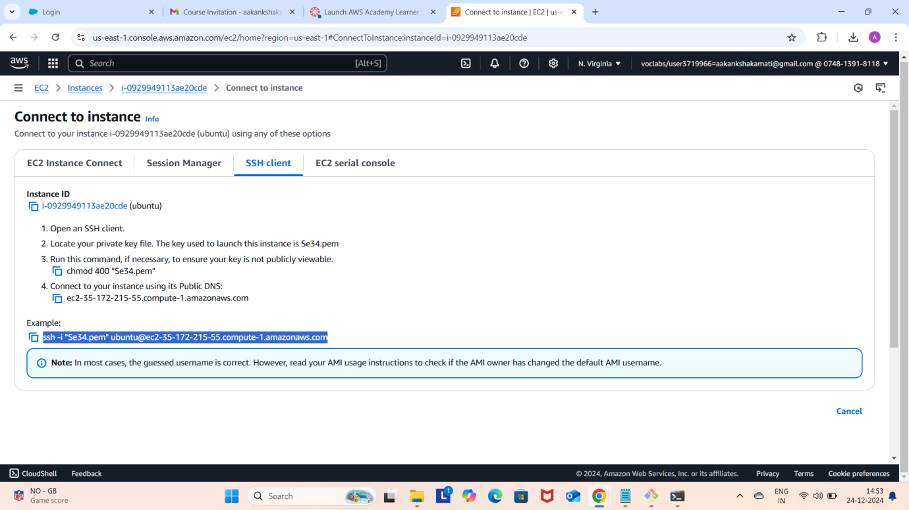

Run the command in the terminal

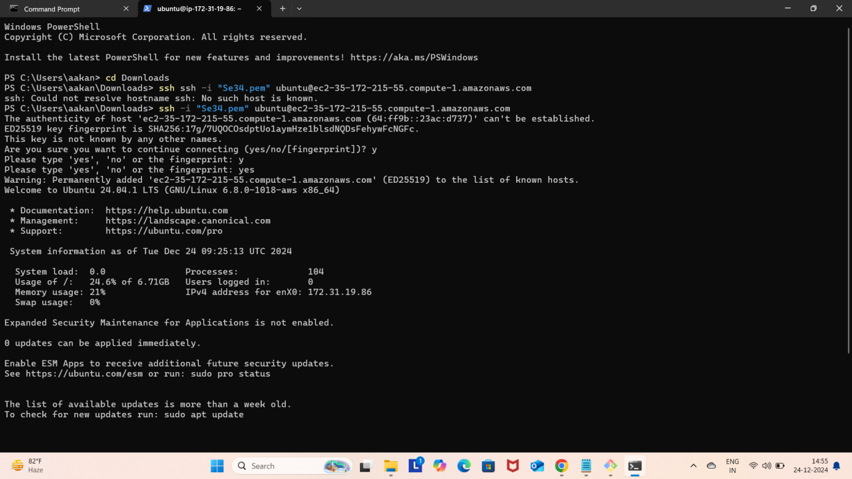

Run the following commands

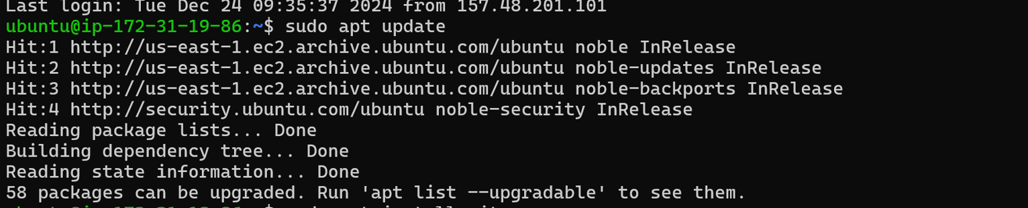

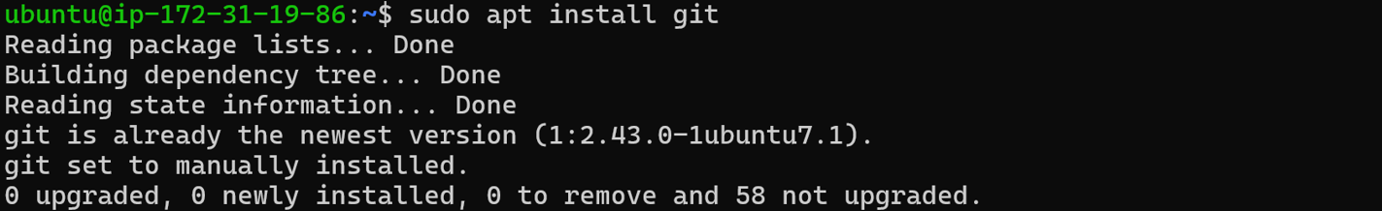

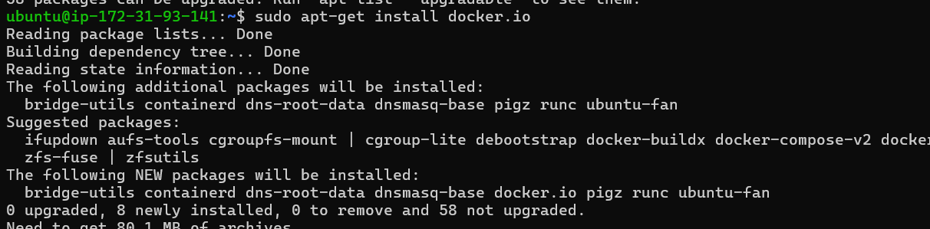

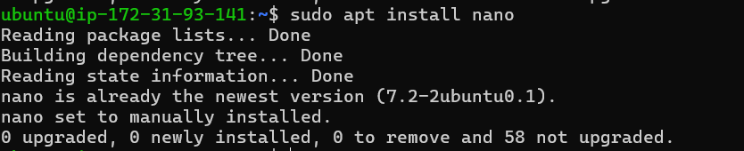

Create basic index.html file

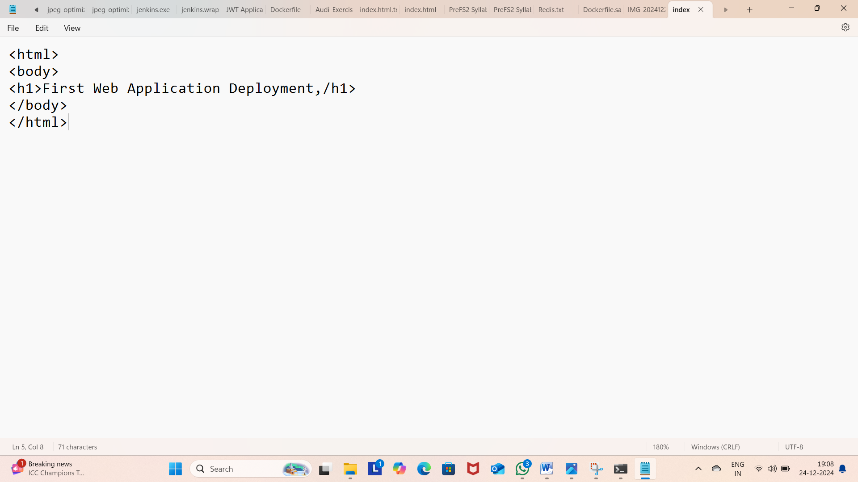

Open git Bash

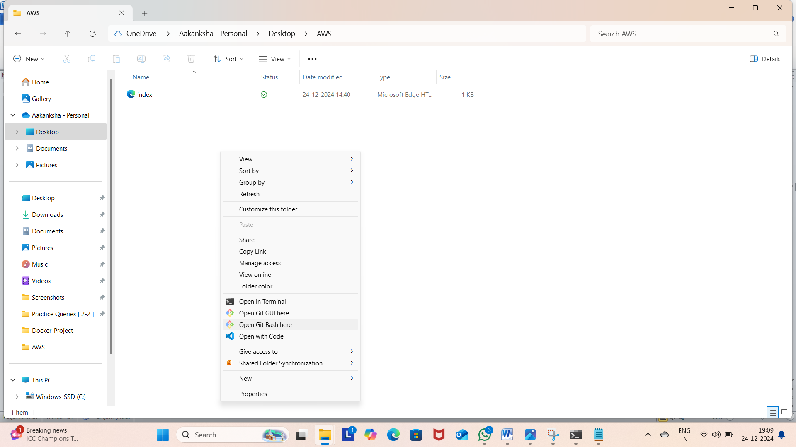

Run the following commands

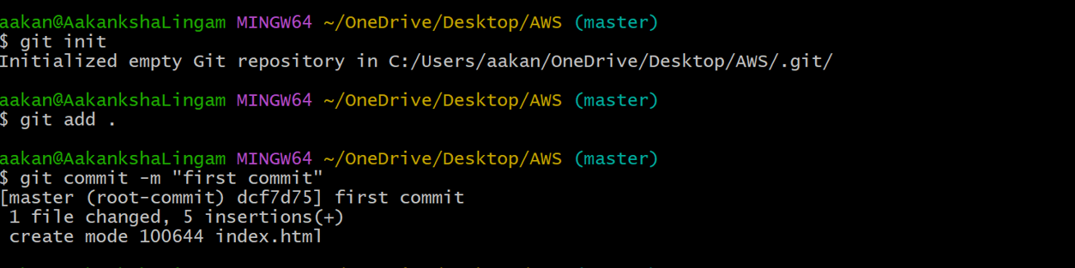

Create git repo

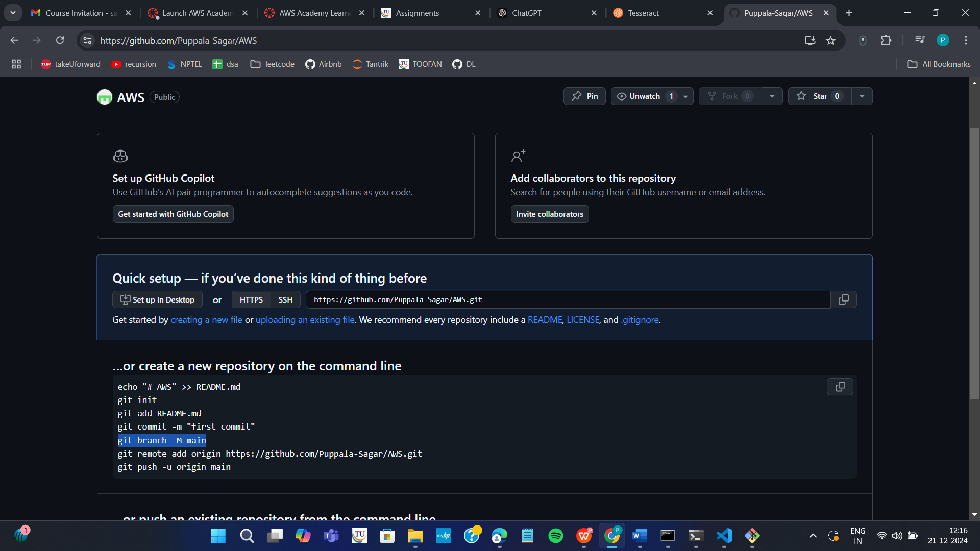

Now run the following commands

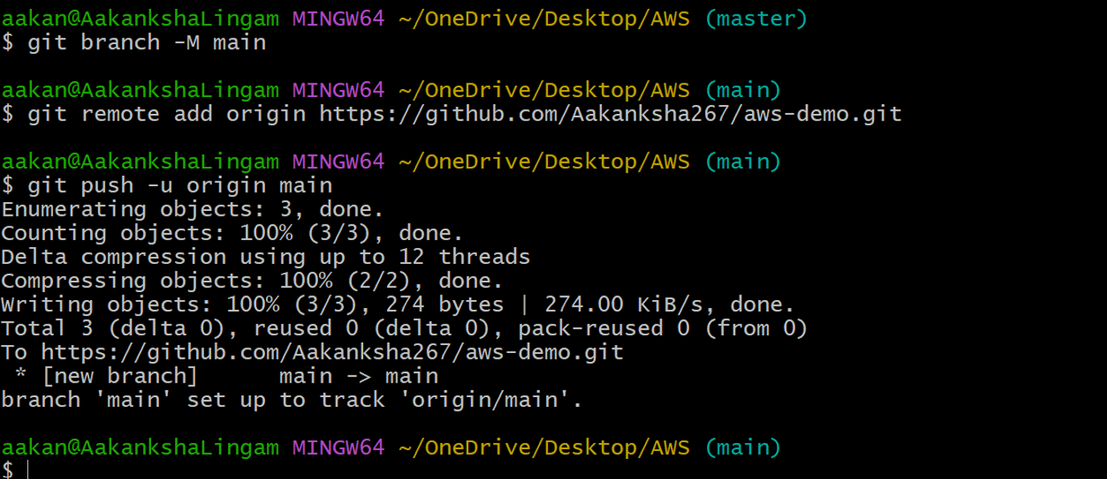

You can now see index.html in github

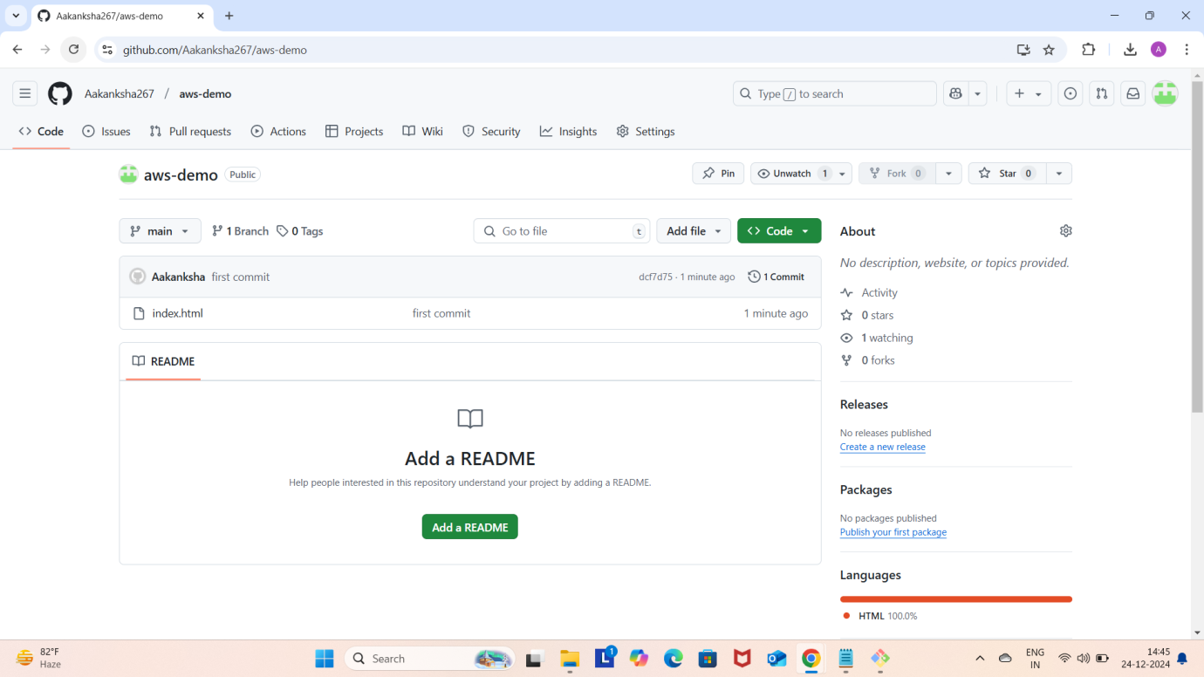

Copy http path

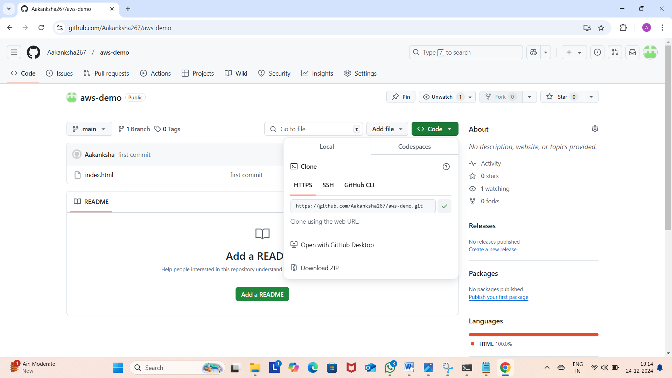

Clone the repository

Navigate to the cloned folder

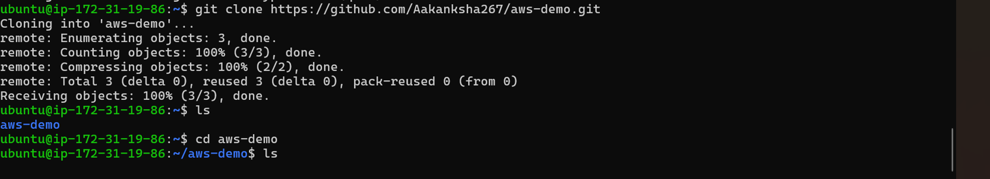

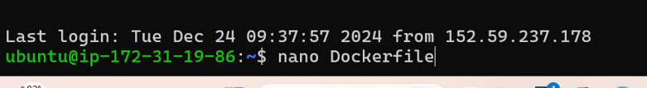

Write the following data in Dockerfile and click ctrl+o and ctrl-x

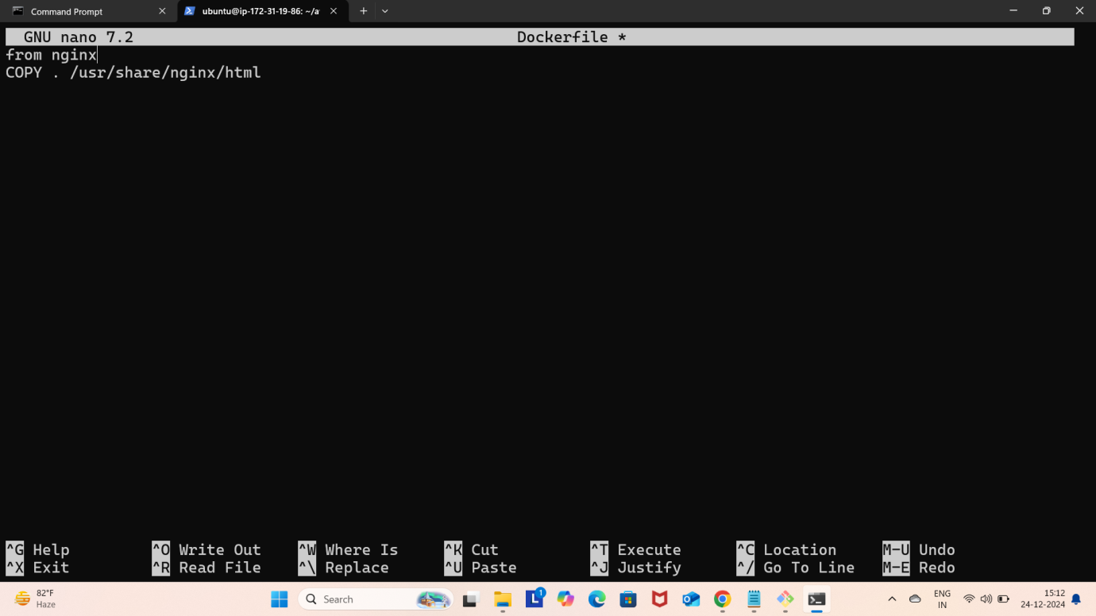

Build docker image by executing the following command

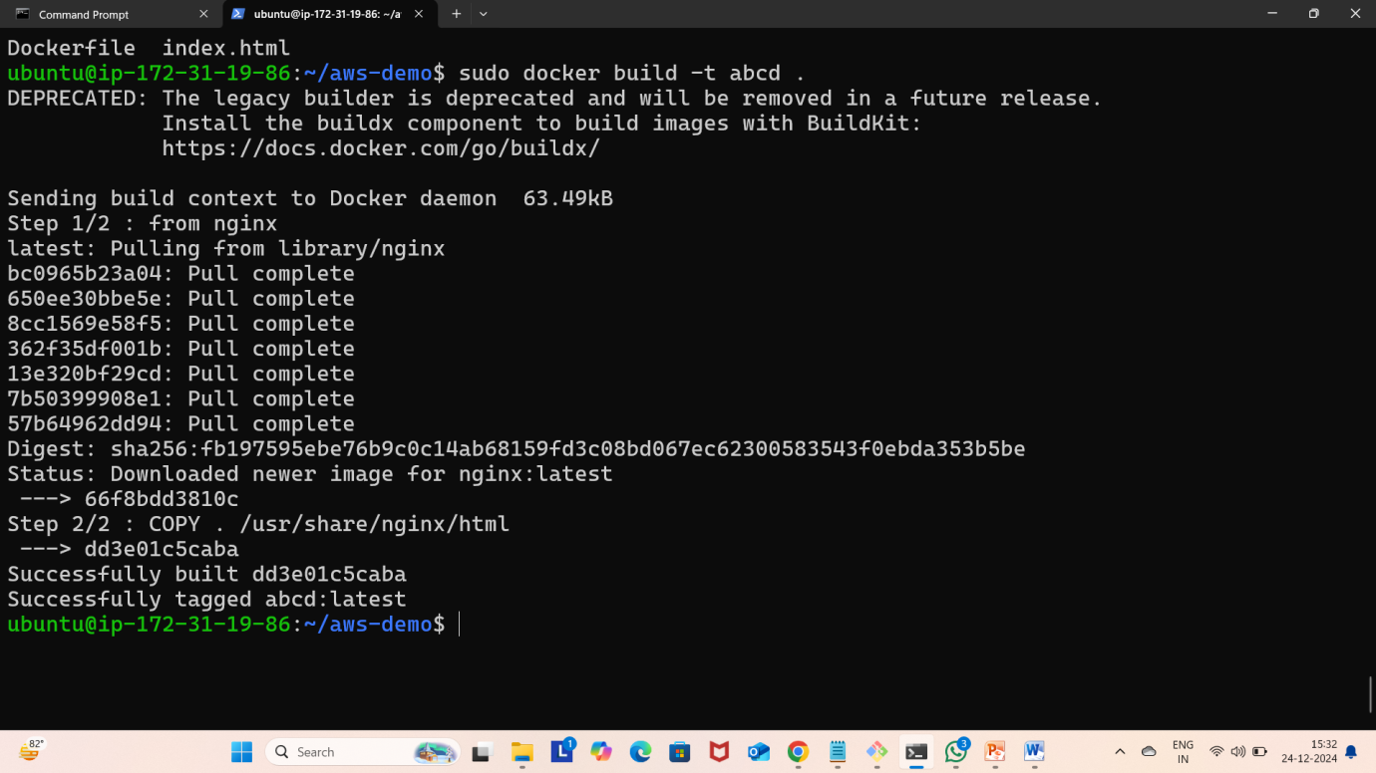

Run the contain

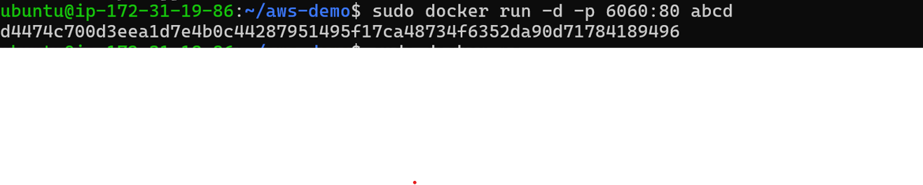Click on

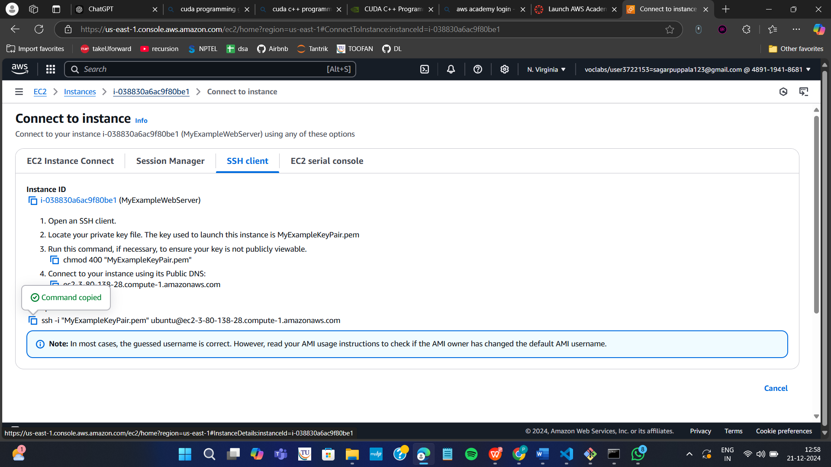



Copy public ip

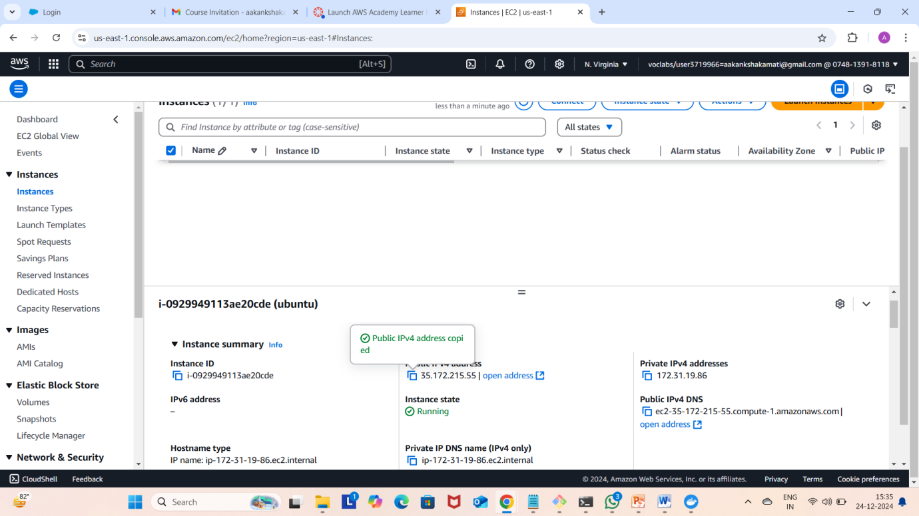

Paste it in the browser

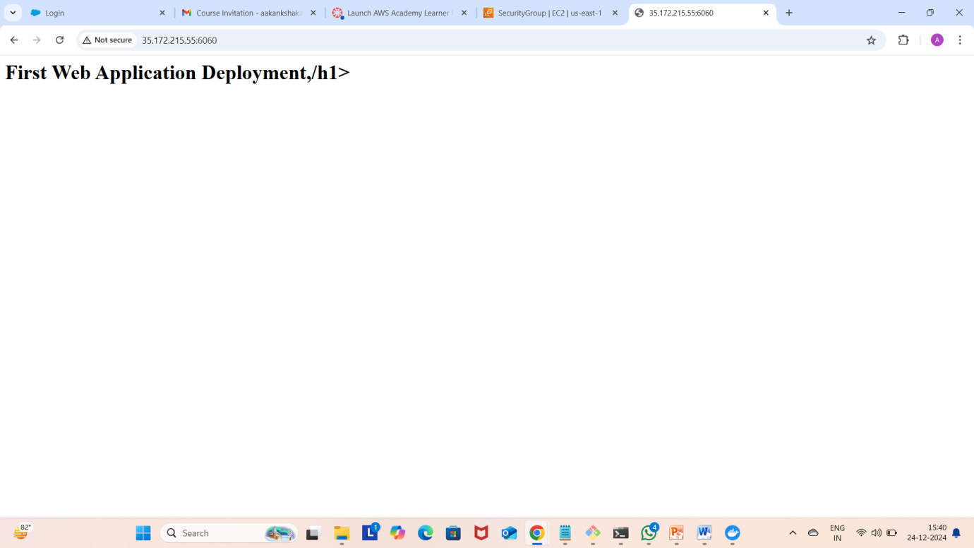

Run the following command to stop the container



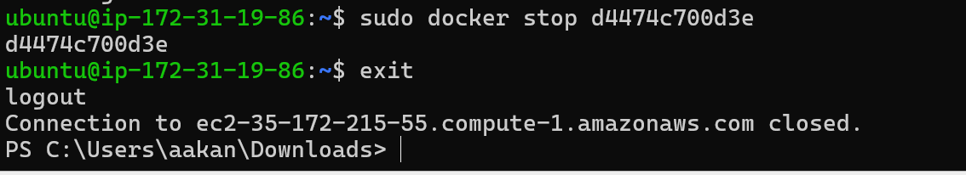

Click on terminate instances

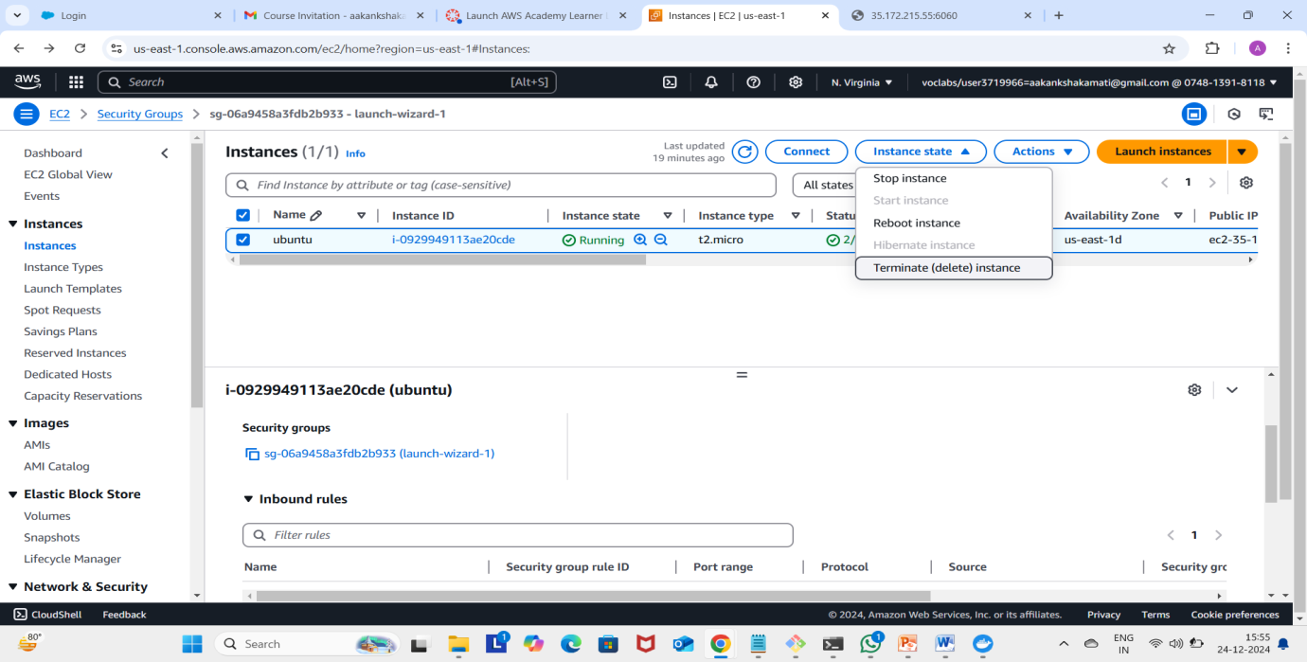

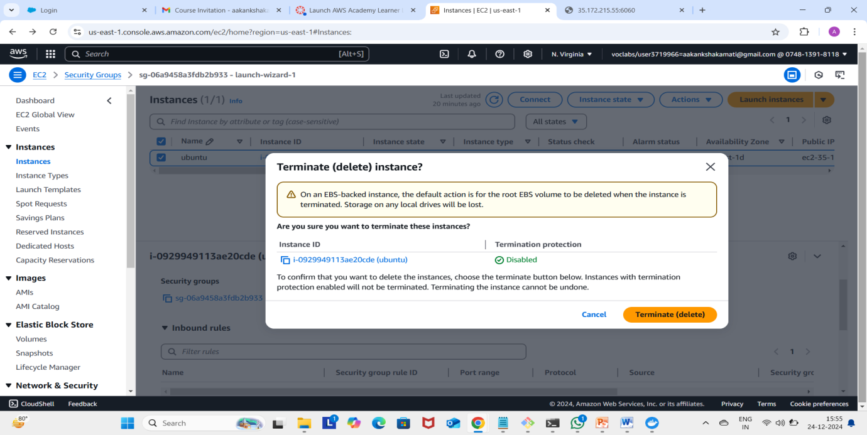

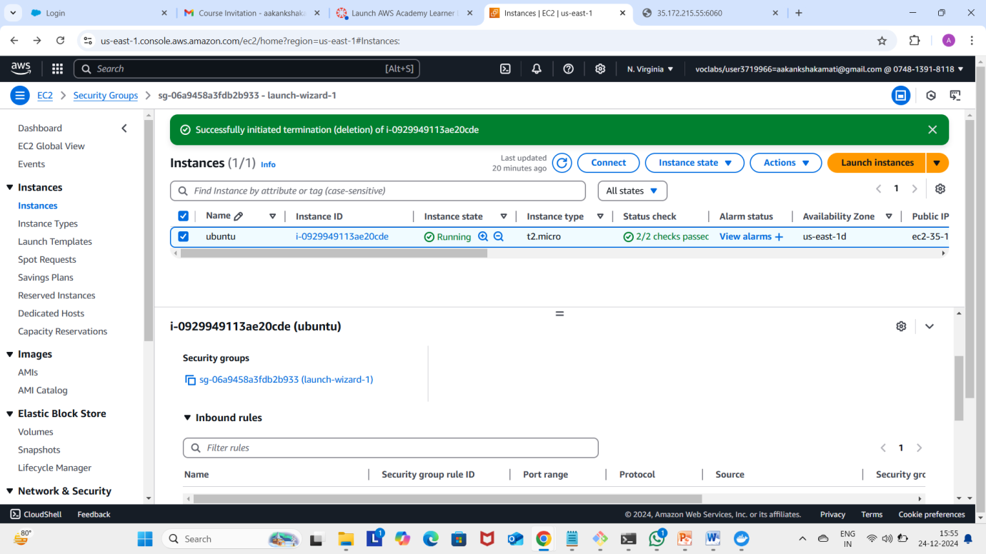

Now click on end lab

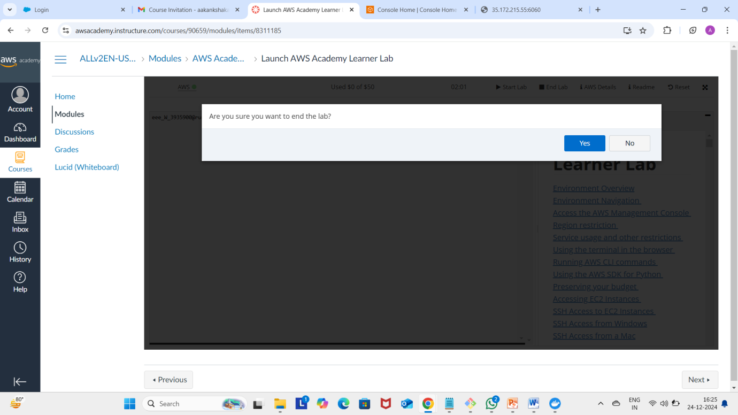

2 MAVEN WEB PROJECT DEPLOYMENT IN AWS

Click on start lab



Click on AWS



Click on EC2



Click on launch instance



Give name

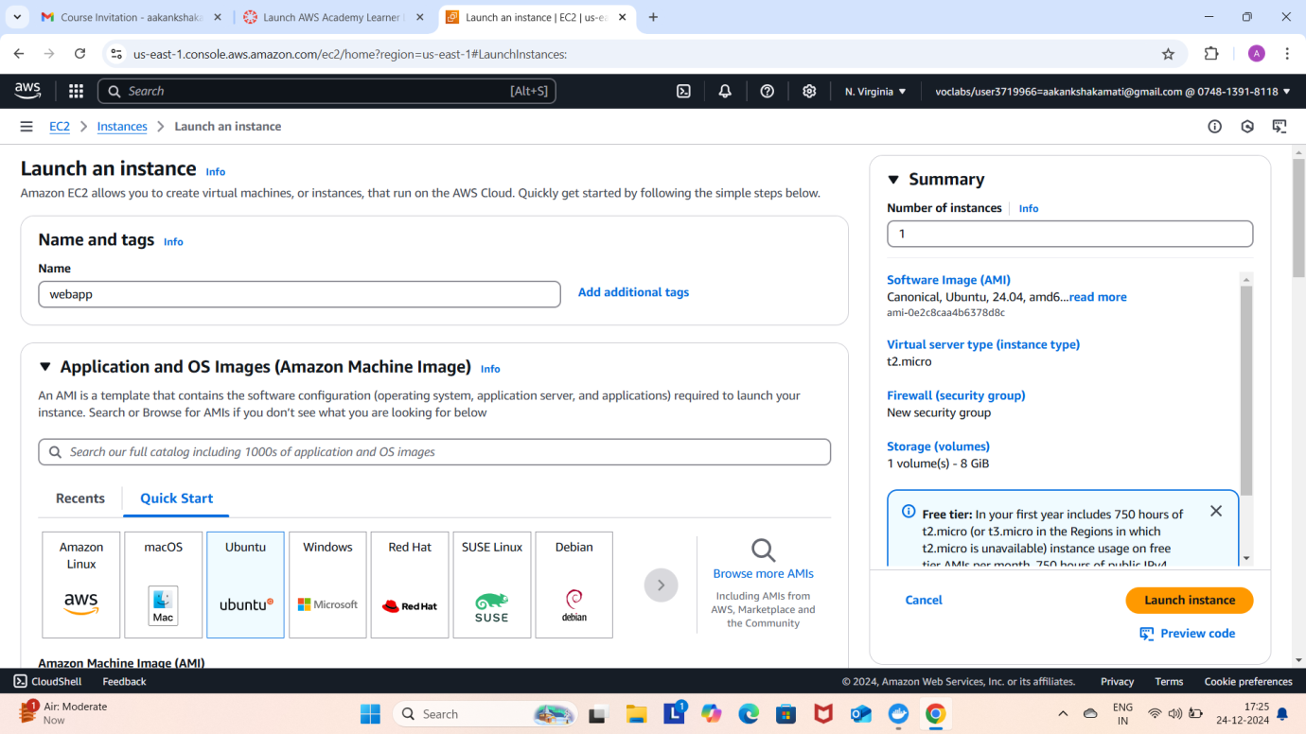

Create new key



Check all the boxes under network and click on launch instance

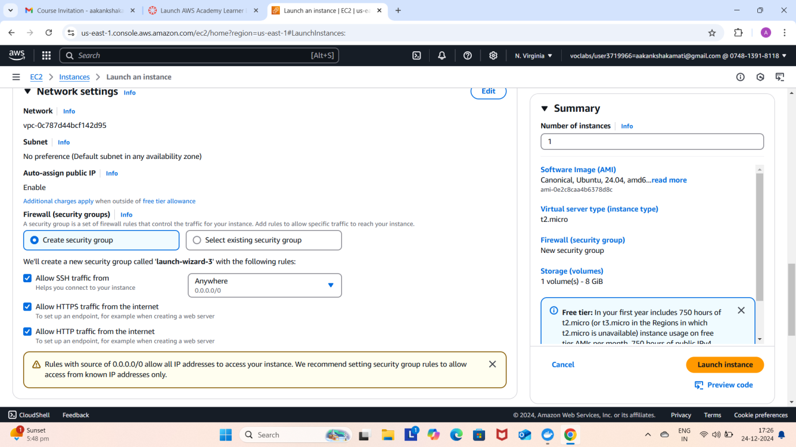

Click on instances

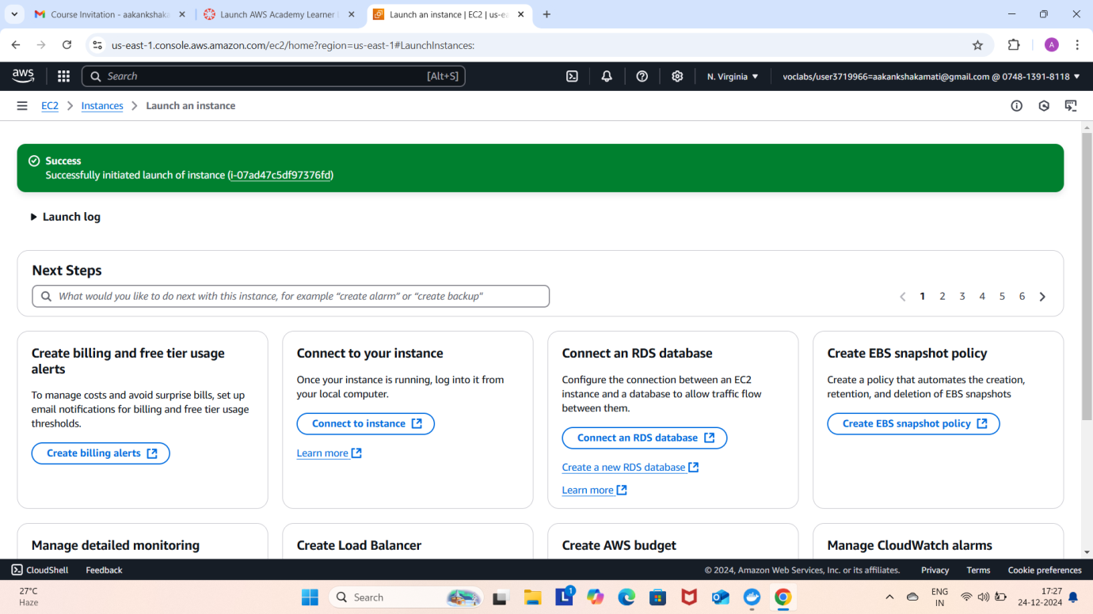

Wait until you get 2 tests passes

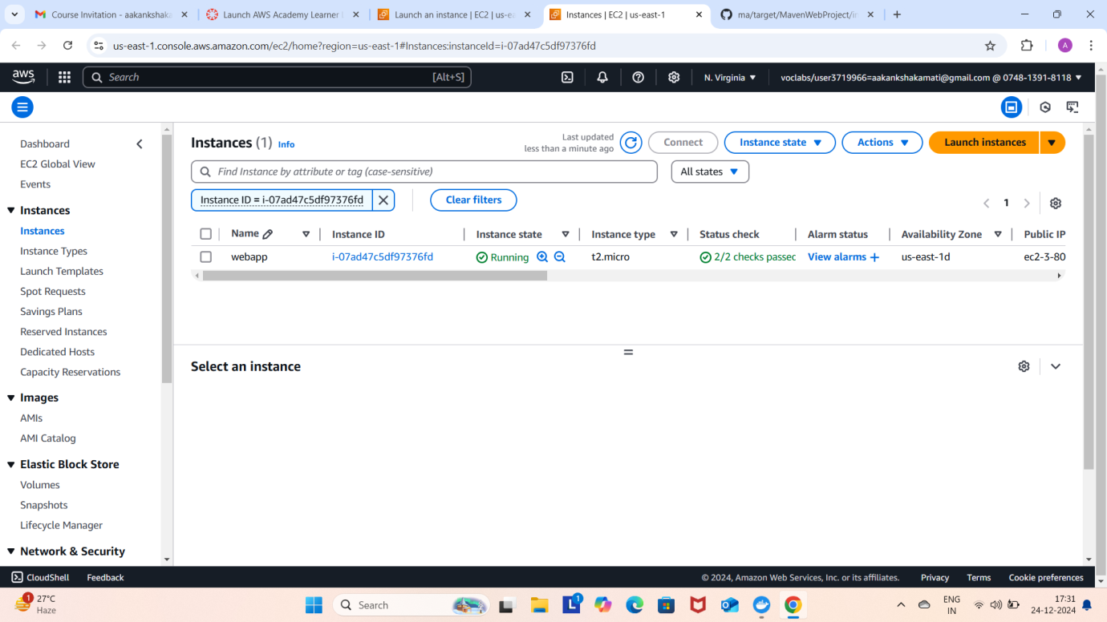

Click on connect after checking the box

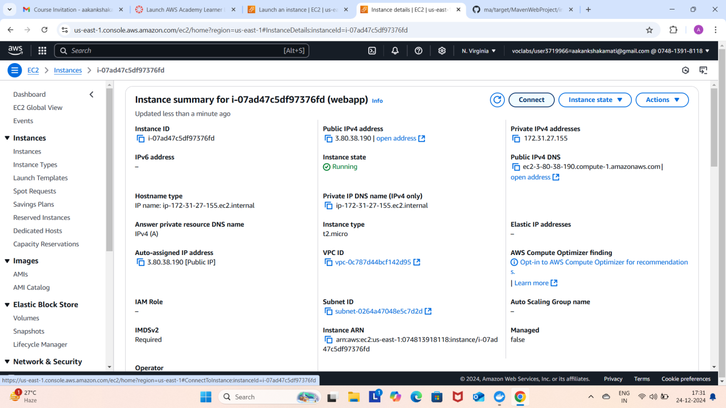

Copy ssh command

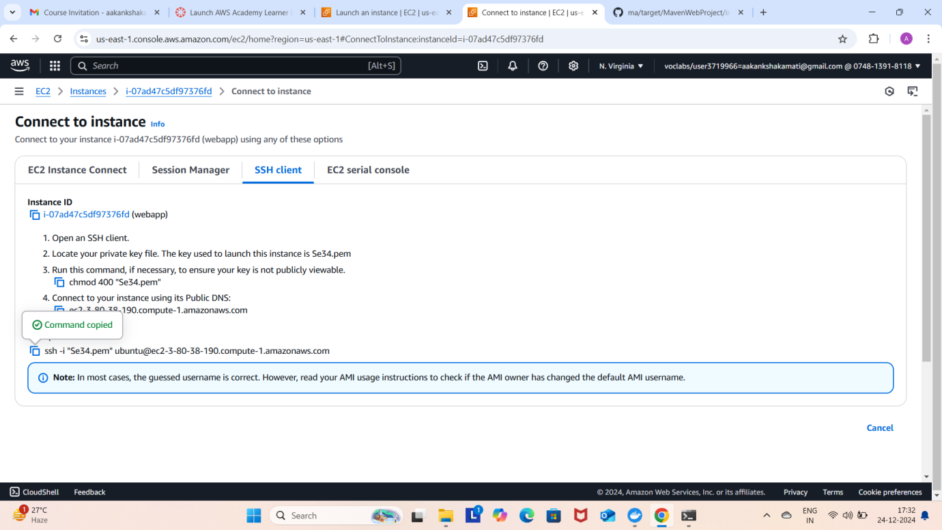

Open the terminal, Navigate to the path



Run the ssh command

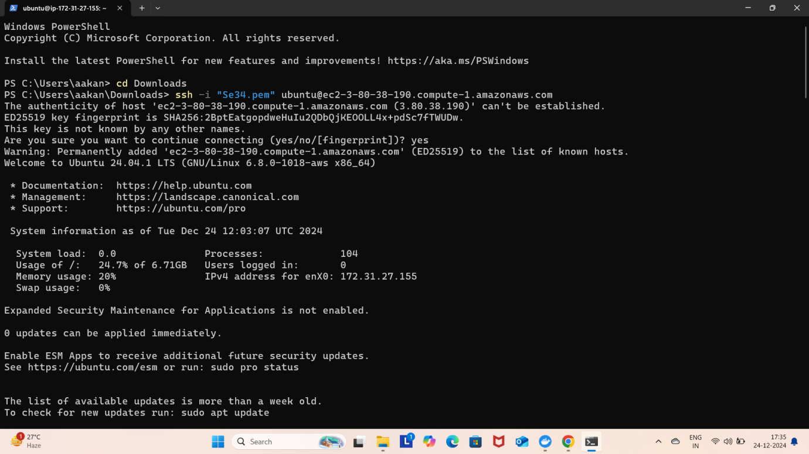

Run the following commands

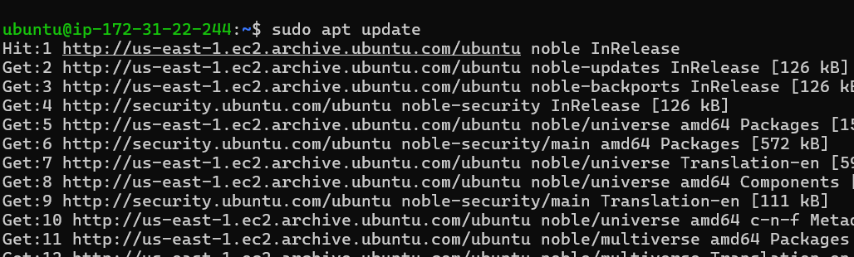

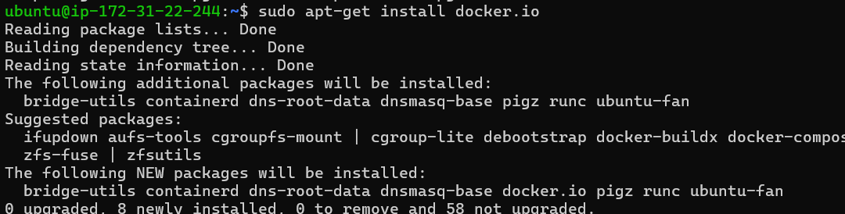

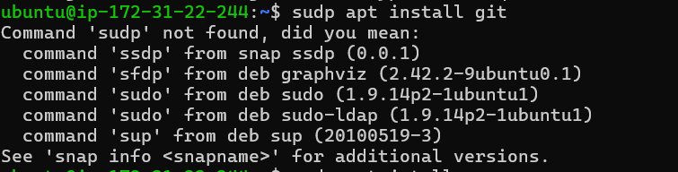

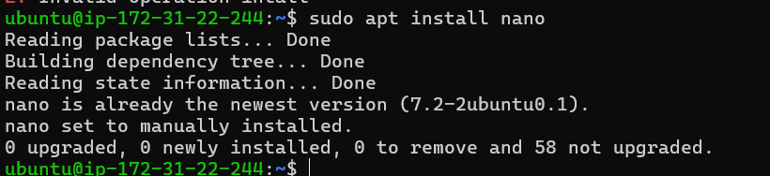

**Open MAVEN WEB PROJECT REPO in github and copy http link**

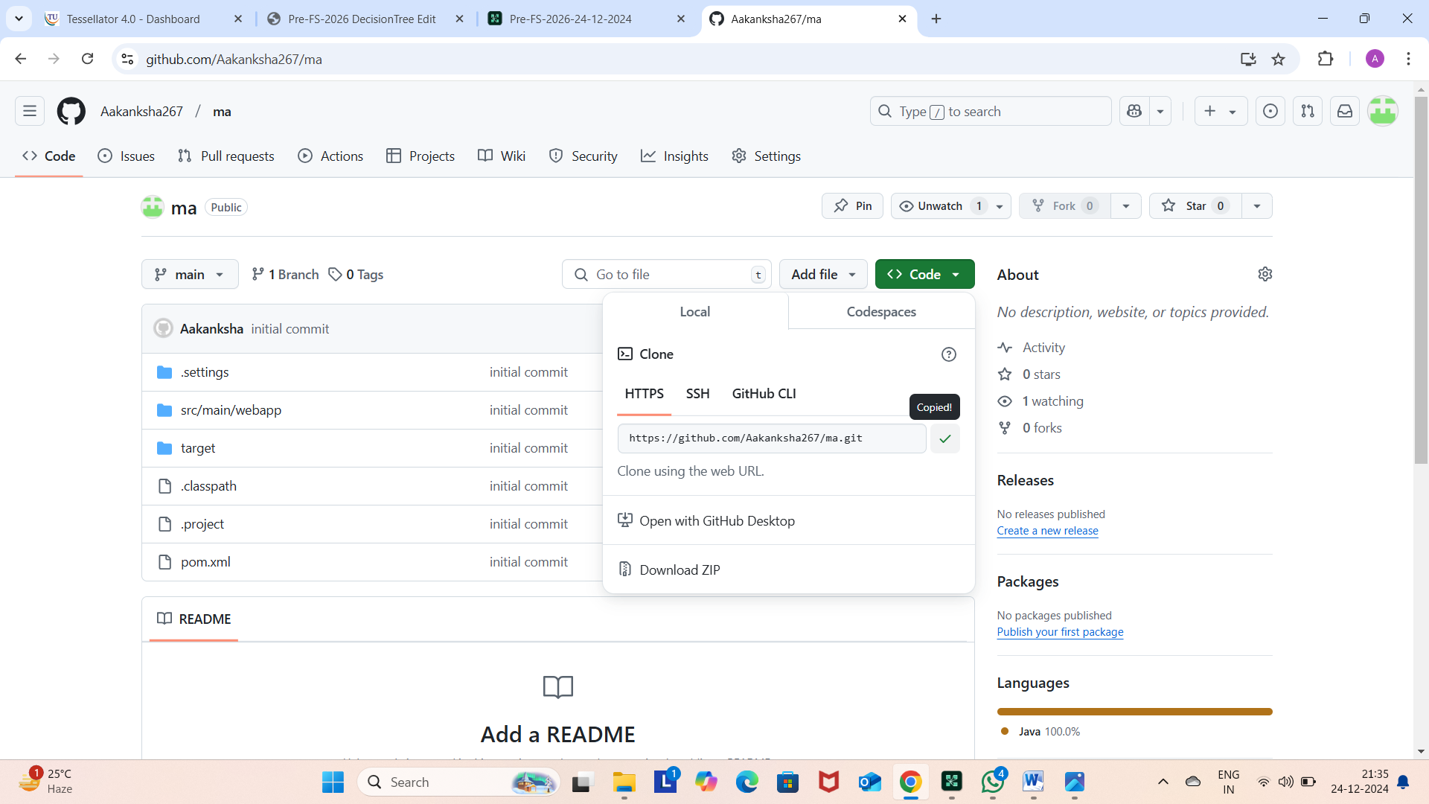

**Clone the repository**

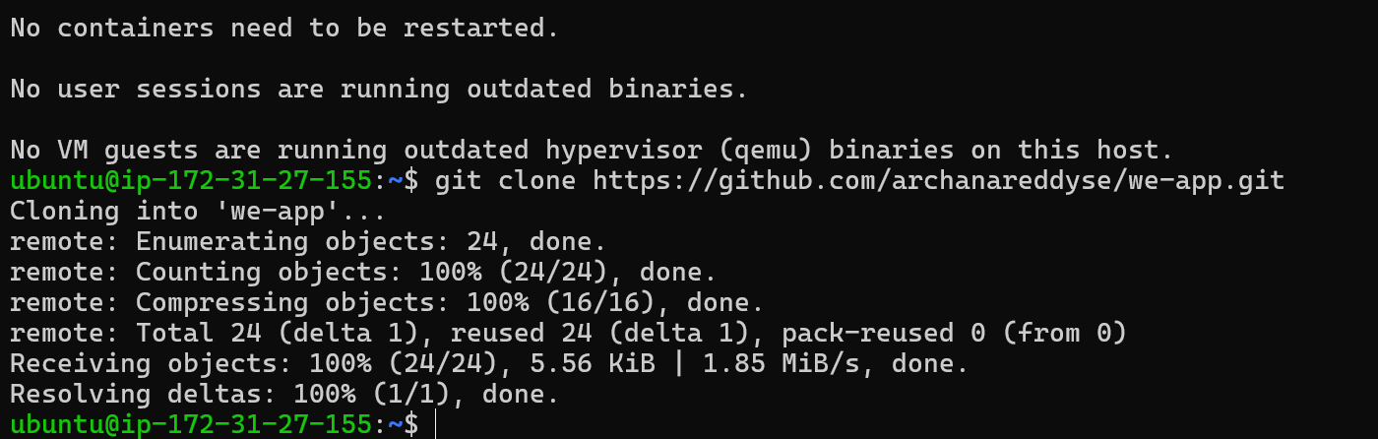

**If your repository is in main run following**

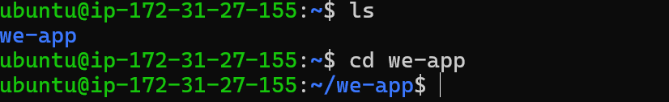

**If not goto your github repo Click on settings Under default branch section click on the icon shown and you’re your master branch as default and execute above commands**





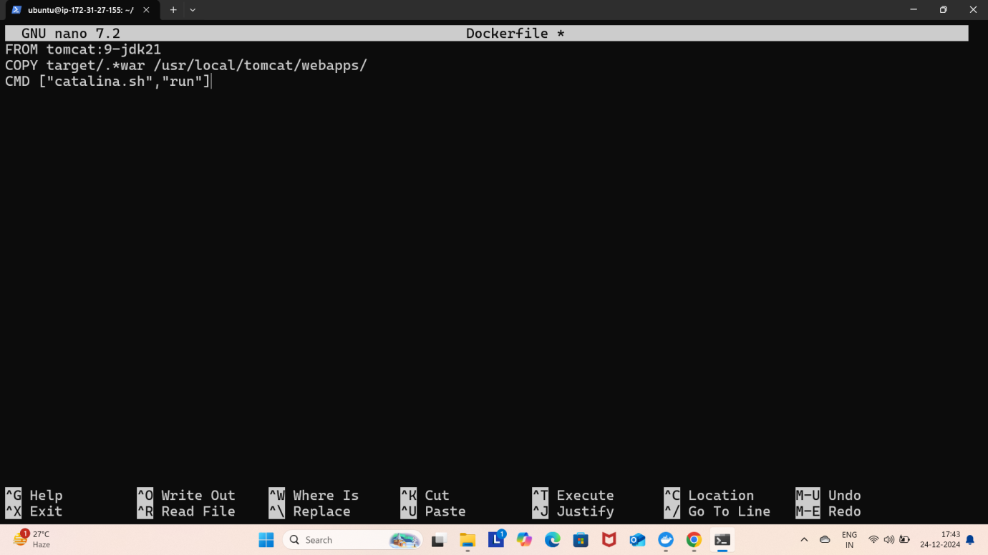

**Build docker image**

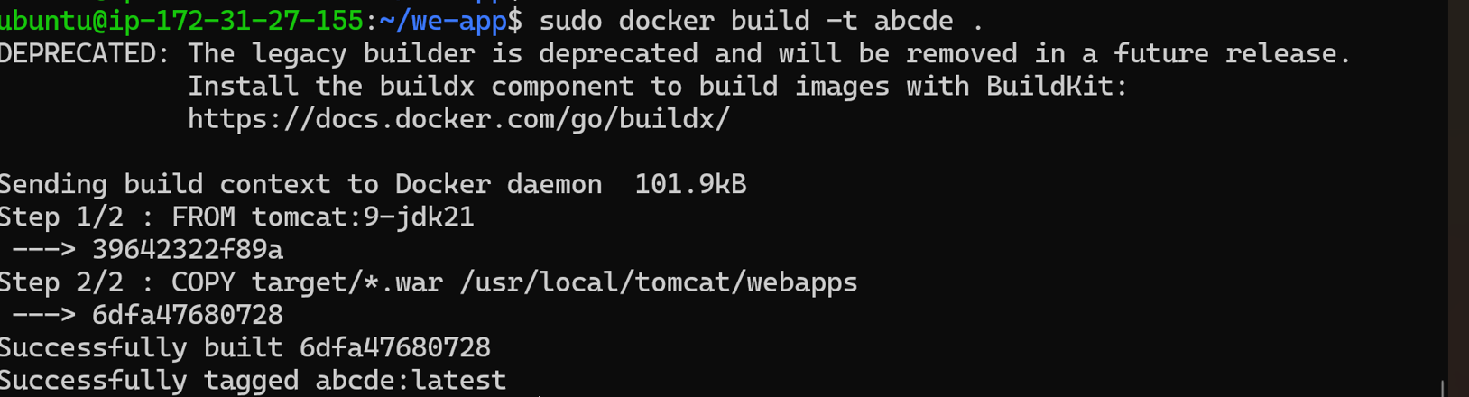

**Run the container**

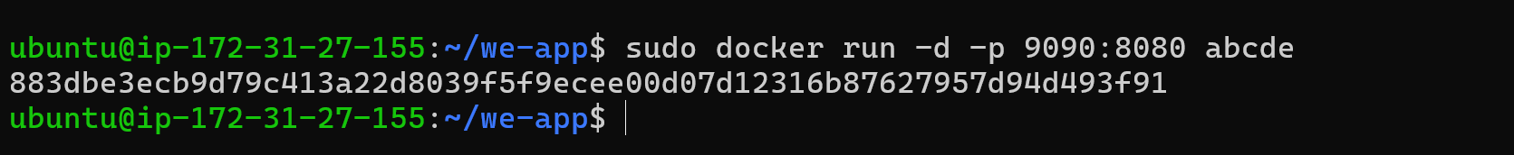

**Copy public ipv4**

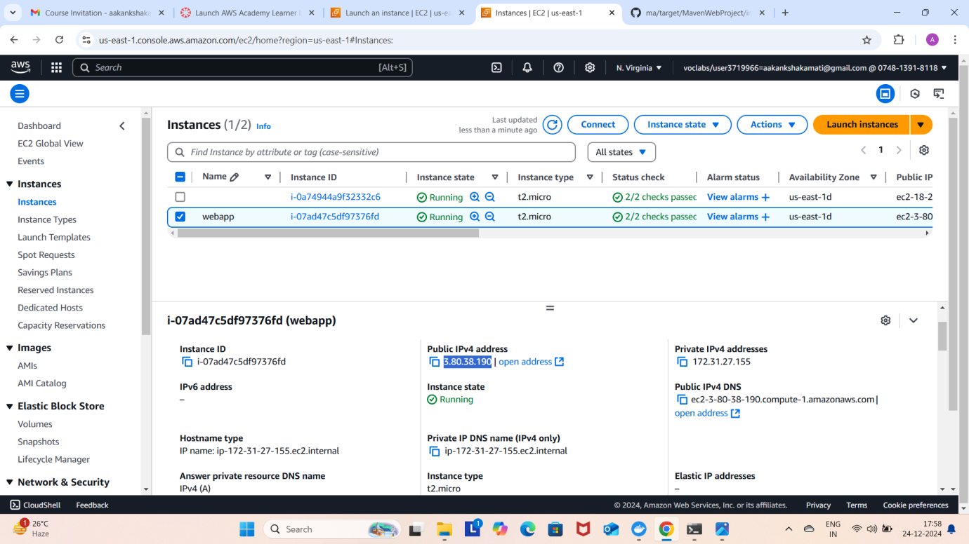

**Enter this url in browser and click enter**

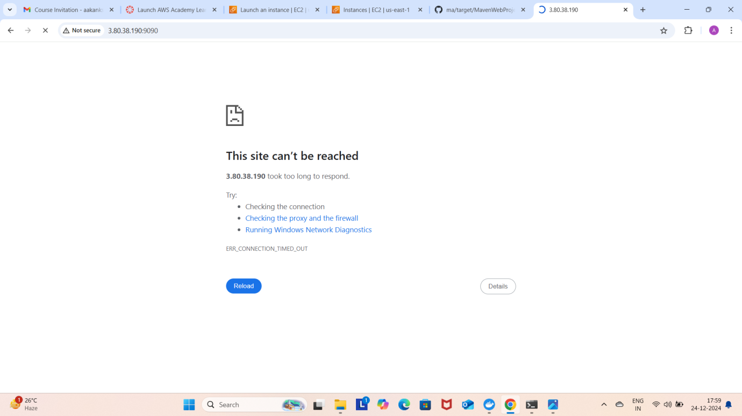

**If your app is not running goto security and Click on security groups**

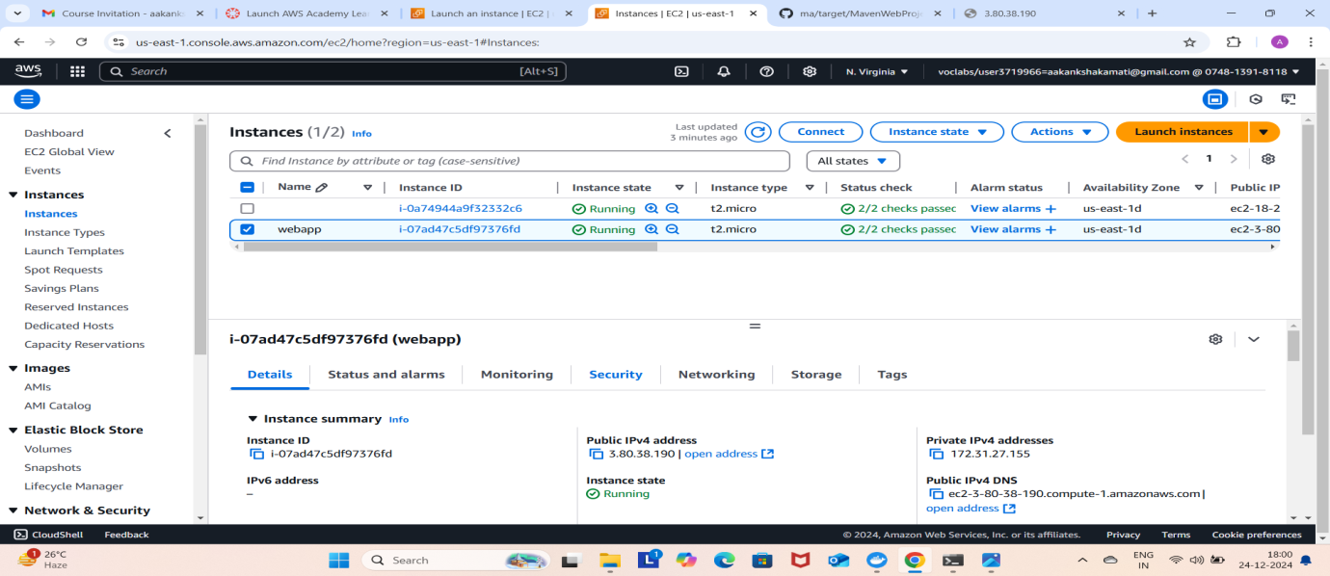

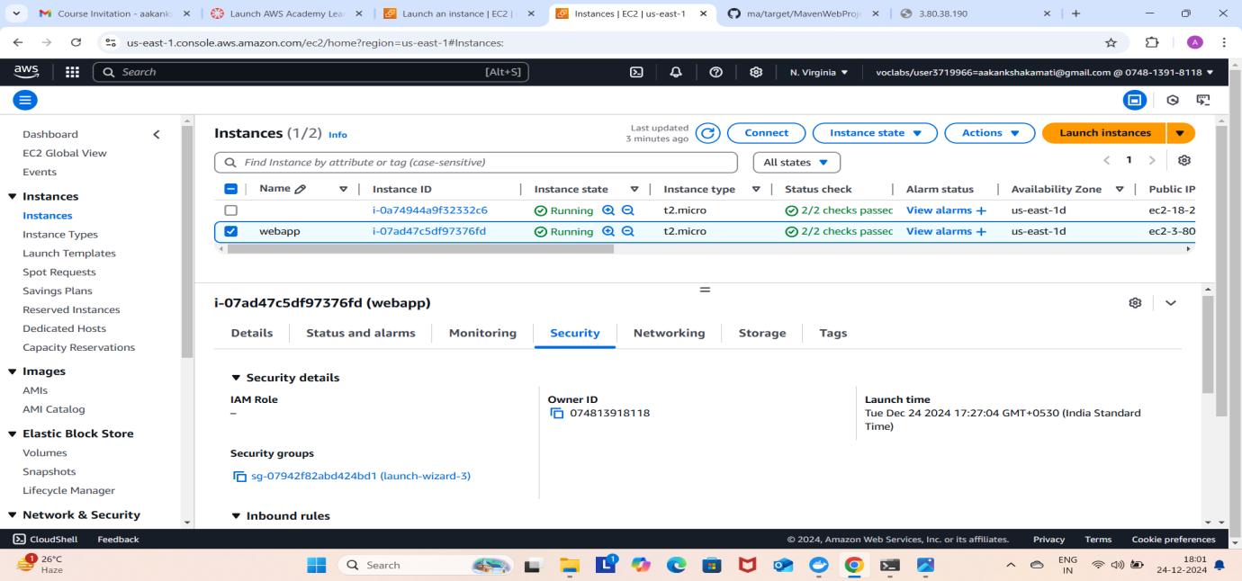

**Click on edit inbound rules**

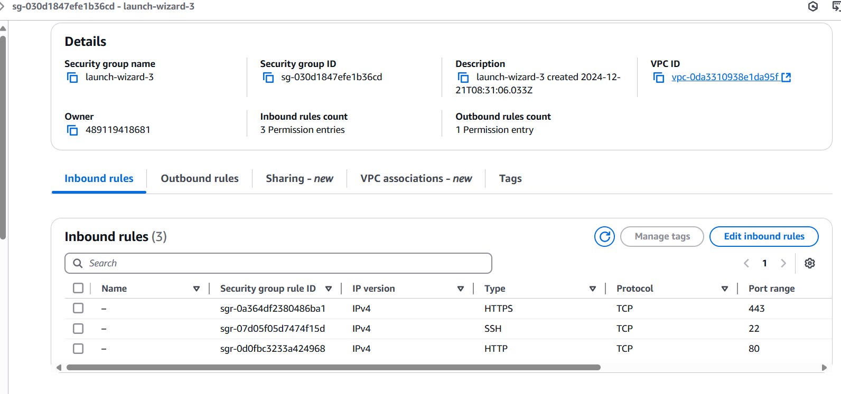

**Click on add rule give port as 9090 and 0.0.0.0/0 click on save**

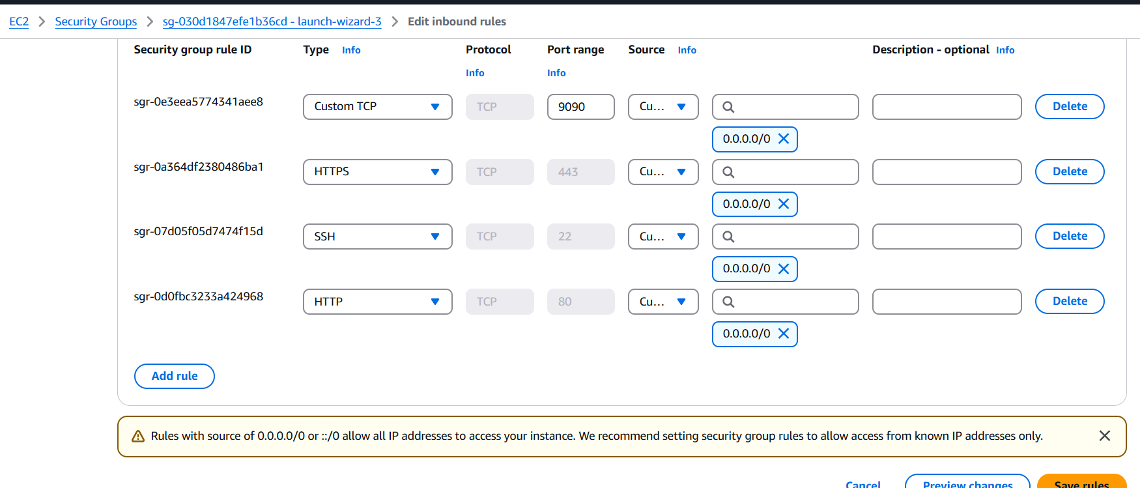

**And refresh the page to check whether the web page has loaded or not**

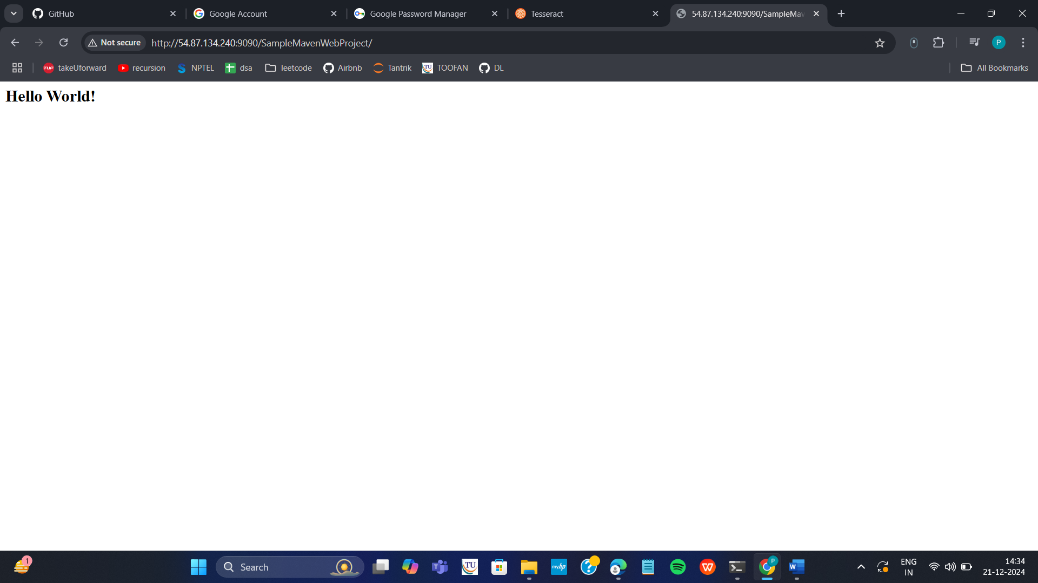

**If it is loaded you have successfully deployed you maven web project In your ec2 instance**

**Run the following commands to stop the container**



**Terminate your instance**

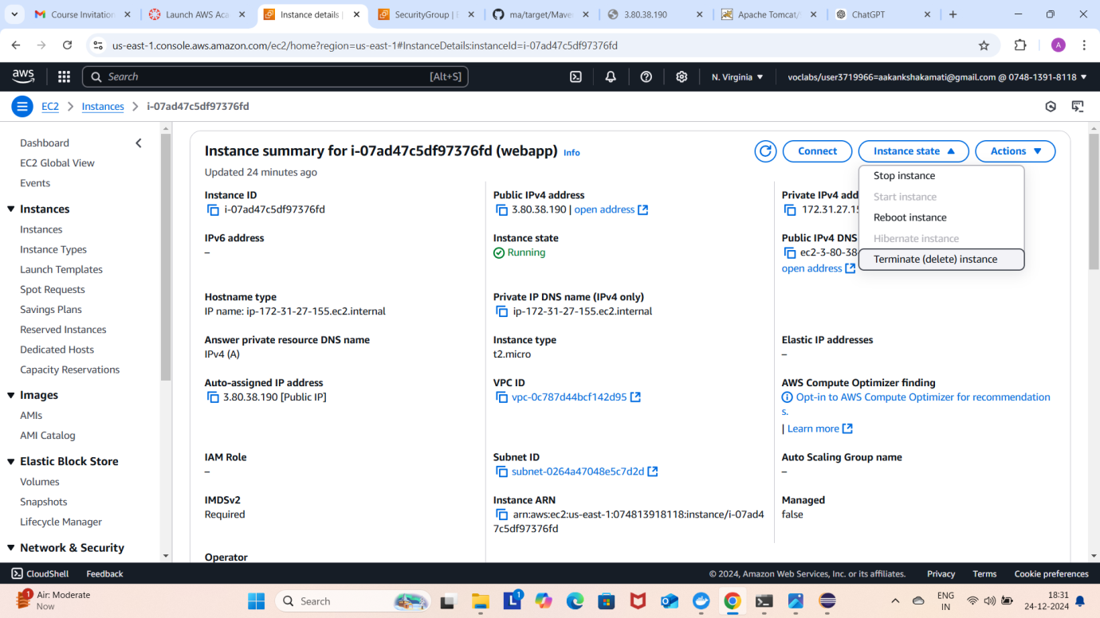

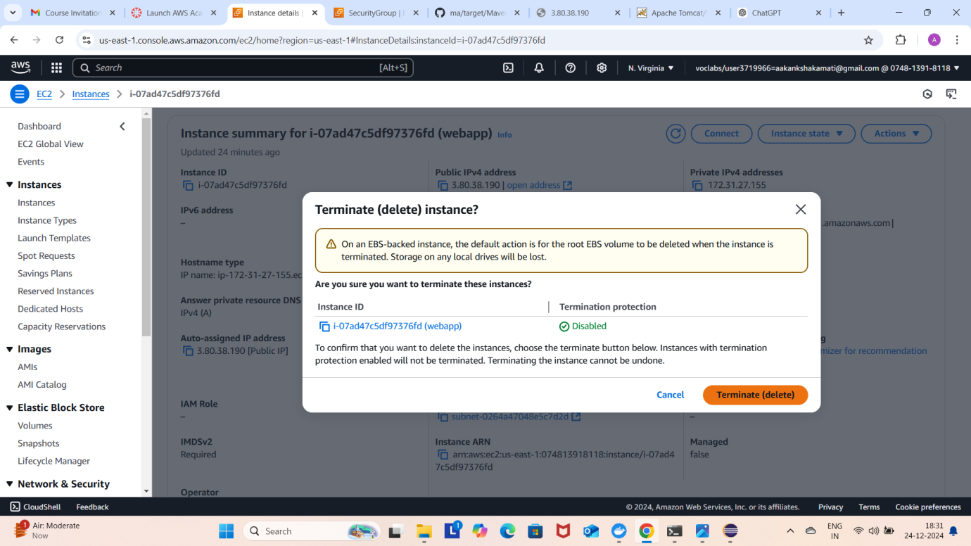

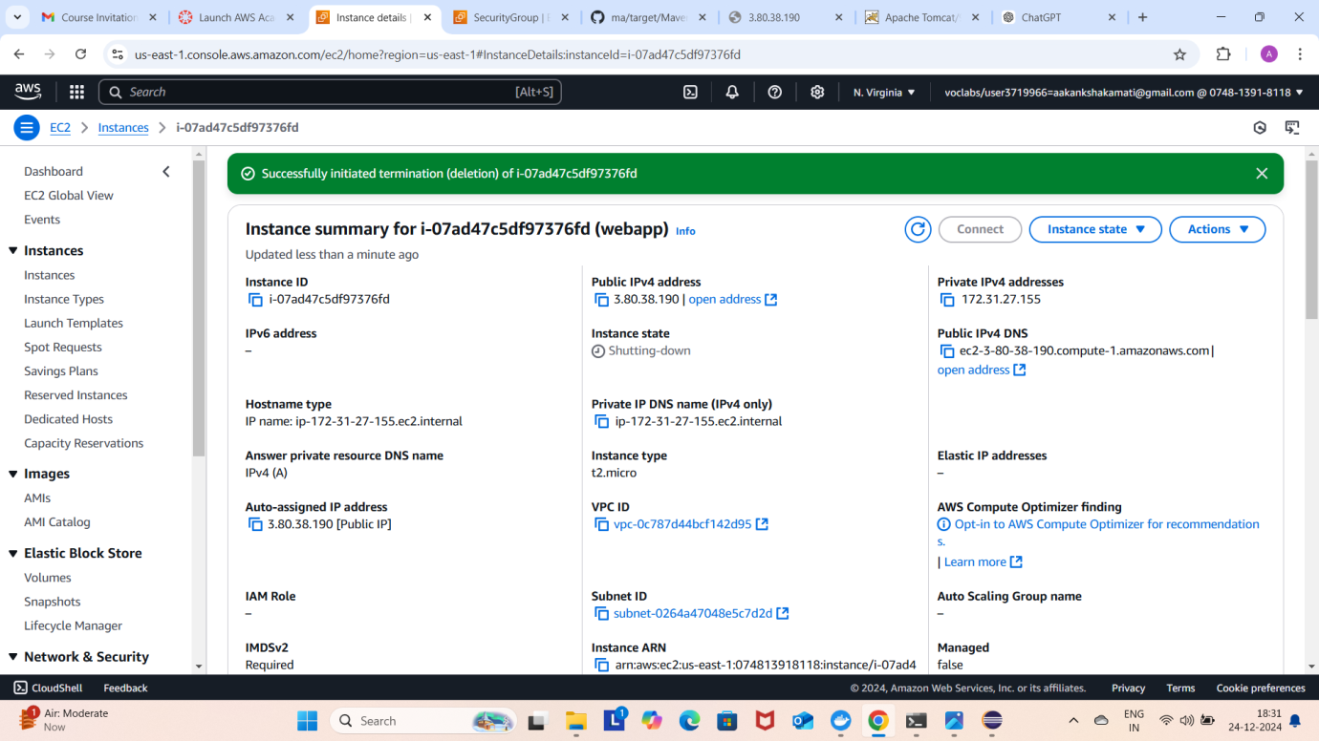

**End your lab**





